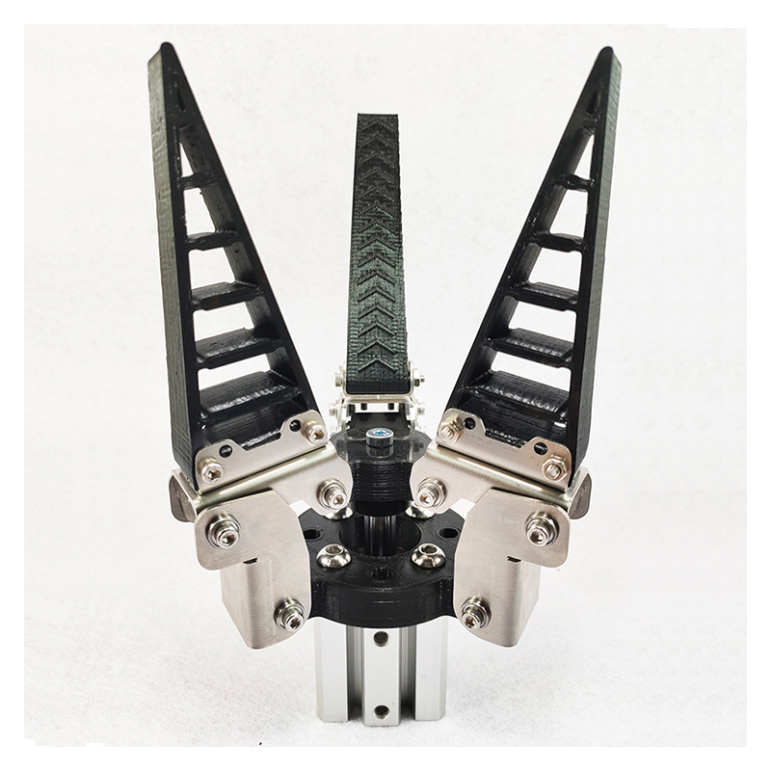
Actions.

Pulling, sliding, pincing

Pulling: All fins are mounted to pivot points on their exterior, they’re mounted to a “plunger” in the middle, when the “plunger" is depressed, the fins all pull inward causing the fins to clap down around the object. May be easier for a 3+ finned grip.

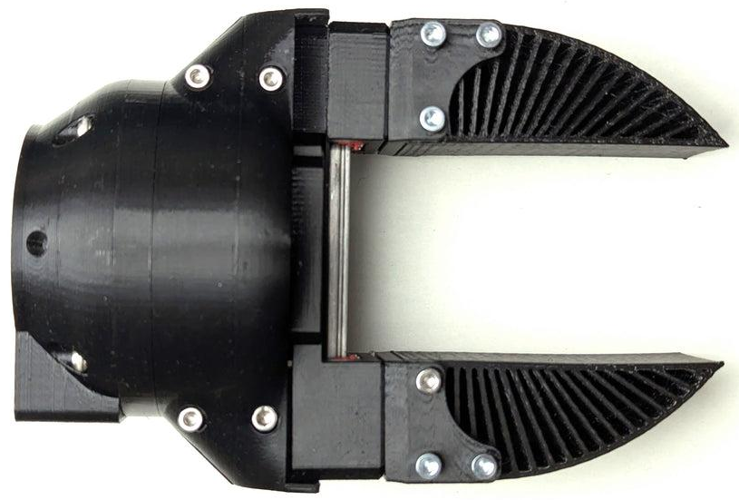
Sliding. Fingers are mounted on some kind of track keeping the bottoms parallel, when the fingers are pulled inward, they collapse inward and grip the object.

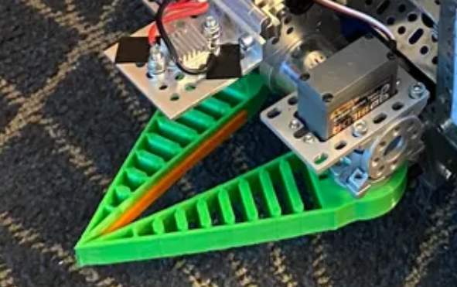
Pinching:motor on either mincer, they rotate it inwards, gripping.

Pulling style with 4 fingers so that there are 2 independent sets.

Constraints of the design:
- Must be able to hold at least 1kg. Should be designed for 1.2-1.3.
- Must be able to push a button that is 1’ by 1’

